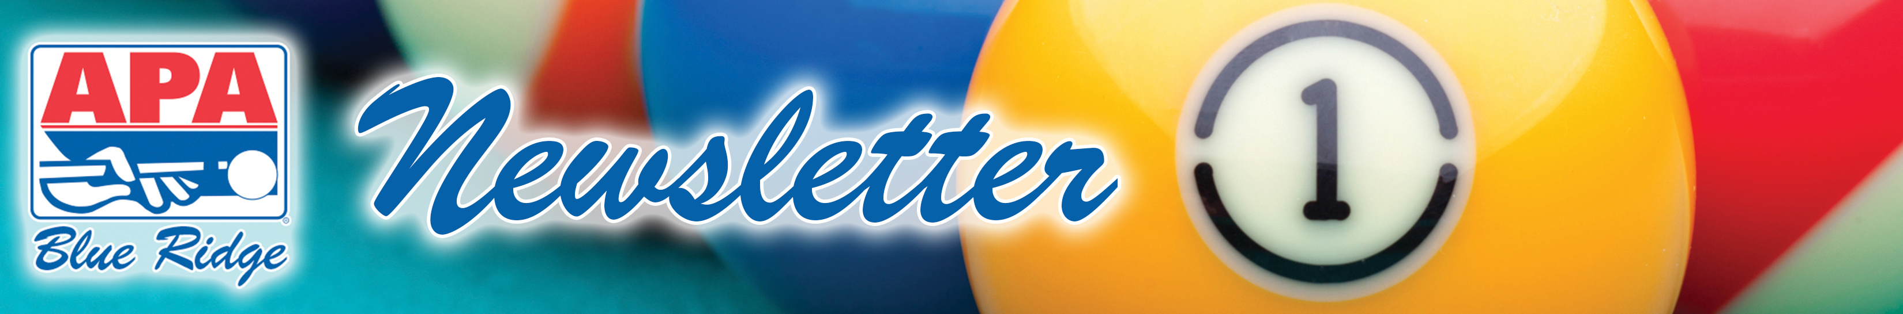

April 7, 2014: Volume XVIII – Issue 13

CUE TIP OF THE WEEK: NO GAMBLING DURING LEAGUE PLAY
The APA is an amateur pool league designed to be fun and fair for everyone. Players are prohibited from gambling during league play AND in a league host location on league night, even if you are not on a team that night. The purpose of this rule is as follows:

- to keep our players honest so as to keep the skill levels more accurate
- to avoid possibly intimidating some of our lower rank players
- to avoid conflict (potentially “upping the stakes” on a match) or the perception of sharking (this includes setting up some action after league play is over)
- to uphold our policy – and overall philosophy – of good sportsmanship

We play for fun... NOT for money! What you do on your own time is your own business, but please don't do it during or close to (immediately before or after) APA time. Violations of this policy could result in loss of league match points, team bonus points, or suspension from league play.


THIS WEEK’S BOUNTY HUNT:
Kat Cone from “Bank Robbers” – there’s a bounty on your head this week. Play and win your match this Sunday at the Ladies 8-Ball division and your match is free! If her opponent (the bounty hunter) wins, then the bounty hunter plays for free!

POOL TABLES AND EQUIPMENT
Some of our host locations have pool tables that are available for practice during league play. Please limit practice on these tables to APA MEMBERS ONLY! It is against the rules to allow your children to play on them or your significant others who are not members of the team. There are a lot of players in the league and very few tables to be shared among them, so please be considerate – use them only for APA team member practice.

SINGLES BOARD SUNDAY!
This Sunday at Fat Cat's we will be running an 8-ball singles board on 9-foot tables to qualify for the singles regional in Charleston! Sign up at 1:45 to play at 2:00pm on the board!


